# Notes

private Touch pinch1;

private Touch pinch2;

Aren't used? Don't dare remove them now.

private Vector2 touchPosition = default;

private Vector2 pinchPosition1 = default;

Always have the same value.

Possible to distinguish between them.

touchPosition for pause

pinchPosition1 is for resizing.

Vector3

Still don't quite get it.

You can use it for position, rotations and scaling ?

OnDisable() OnEnable()

Is called when the object the script is attached to is toggled. i.e. when start or close the app.

Update()

Happens every tick (frame). So with heavy functionality, the app may get lag because it then has to wait every time for update to finish

Awake()

Starting up

[SerializeField]

Creates a field that you so see in the unity editor where you add the objects.

Regel 73 & 78 - (float)#.##

Sometimes necessary because it only wants to do calculations with two of the same type and C# doesn't know whether 0.95 is a float, double etc. By putting (float) in front of it, you indicate what type it should be.

Object.transform

Refers to the script at the top of the inspector in unity. The rotation, position and size (rotation, position, localScale).

try {} catch (Exception e) {}

When there is an error, the catch catches it so the app doesn't crash.

The try catch should never be in the catch but put in just to be sure

Remove //TODO (line 173) ?

//TODO proper exception handling ?

OnTrackedImagesChanged(ARTrackedImagesChangedEventArgs eventArgs)

“Constructors” part:

<https://docs.unity3d.com/Packages/com.unity.xr.arfoundation@2.1/api/UnityEngine.XR.ARFoundation.ARTrackedImagesChangedEventArgs.html>

Sources:

<https://docs.unity3d.com/Packages/com.unity.xr.arfoundation@5.1/manual/features/image-tracking.html>

<https://docs.unity3d.com/Packages/com.unity.xr.arfoundation@5.1/manual/features/raycasts.html>

# Raycasting

**It's simply a way to shoot a line and see if it hits a collider. If it hits a collider, you can get useful information about it. It's used for gathering information in 3D space using the physics engine.**

- Ray is where something starts at a point, and then creates a line (you cannot see) in some direction away. The idea is that it then follows this line to see if it collides with anything.

In Physics, the collision is used to detect that something is that direction, or finding out whats in front. I.e. if you have a space ship flying forward, and a raycast from the ship forward collides with an asteroid. Now your AI makes the ship go turn or stop.

In Rendering, a RayCast is an operation from the camera point sending out a "ray" find the surface it collides with and then render the material on that surface for that pixel in the screen. Additionally, light sources may cast rays, and see if that shows a reflection on that material.

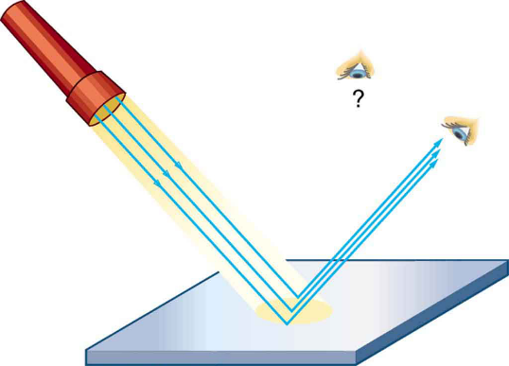

**TODO**

* Removing object when out of view
  + eventArgs.removed doesn't seem to be called ?
* Fit video to image size: is nu 0.2 maar dan moet ie ook 0.2 op scherm (of geprint zijn). Werkt misschien nog als je Specify size deselect?
  + Measure image and edit images size in the ref image library
  + Als goed is past ie zich aan op gescande plaatje
* Needed: Playback or forward option.

TODO as;

* nieuwe images/videos. done
* image size testen.
* Afbeeldingen printen.
* screenshots maken.
* screencapture maken.
* Cool to have; 3D plaatje ipv platte video
  + <https://docs.unity3d.com/2018.3/Documentation/Manual/vuforia_get_started_displaying_3d_content.html>
  + <https://blog.immersive-insiders.com/ar-foundation-image-tracking/>
  + <https://www.andreasjakl.com/2d-image-tracking-with-ar-foundation-part-4/>

**Submission**

Github repository (clone of the repository should work without errors)

Final presentation

Short report 1-3 pages: app description, wat incluinding? AR features? What does the app?